French Military Programming Act 2024-2030 Compliance for Log360
Tagline: Support infrastructure security with real-time threat detection from Log360.

Overview
The French Military Programming Act 2024-2030 (LPM) Compliance extension for Log360 helps French critical infrastructure operators and defense-adjacent organizations meet the enhanced cybersecurity monitoring, incident reporting, and resilience obligations introduced under the LPM.
Log360 continuously collects and correlates logs from operational technology, IT systems, cloud platforms, and network infrastructure, providing security teams with continuous visibility into potential threats. Compliance teams can track control effectiveness and generate ANSSI-aligned audit evidence.

Key Features
- Generate audit reports covering LPM security monitoring requirements for critical infrastructure, including access control, incident detection, and network security events.
- Centralize log data from across your infrastructure to maintain real-time visibility into user activity and access patterns, supporting proactive threat identification and compliance posture.
- Monitor privileged access events, critical system changes, and network anomalies across LPM-regulated environments in real time.
- Export compliance documentation in PDF and CSV formats for ANSSI reporting, supervisory authority submissions, and internal governance.



Screenshots
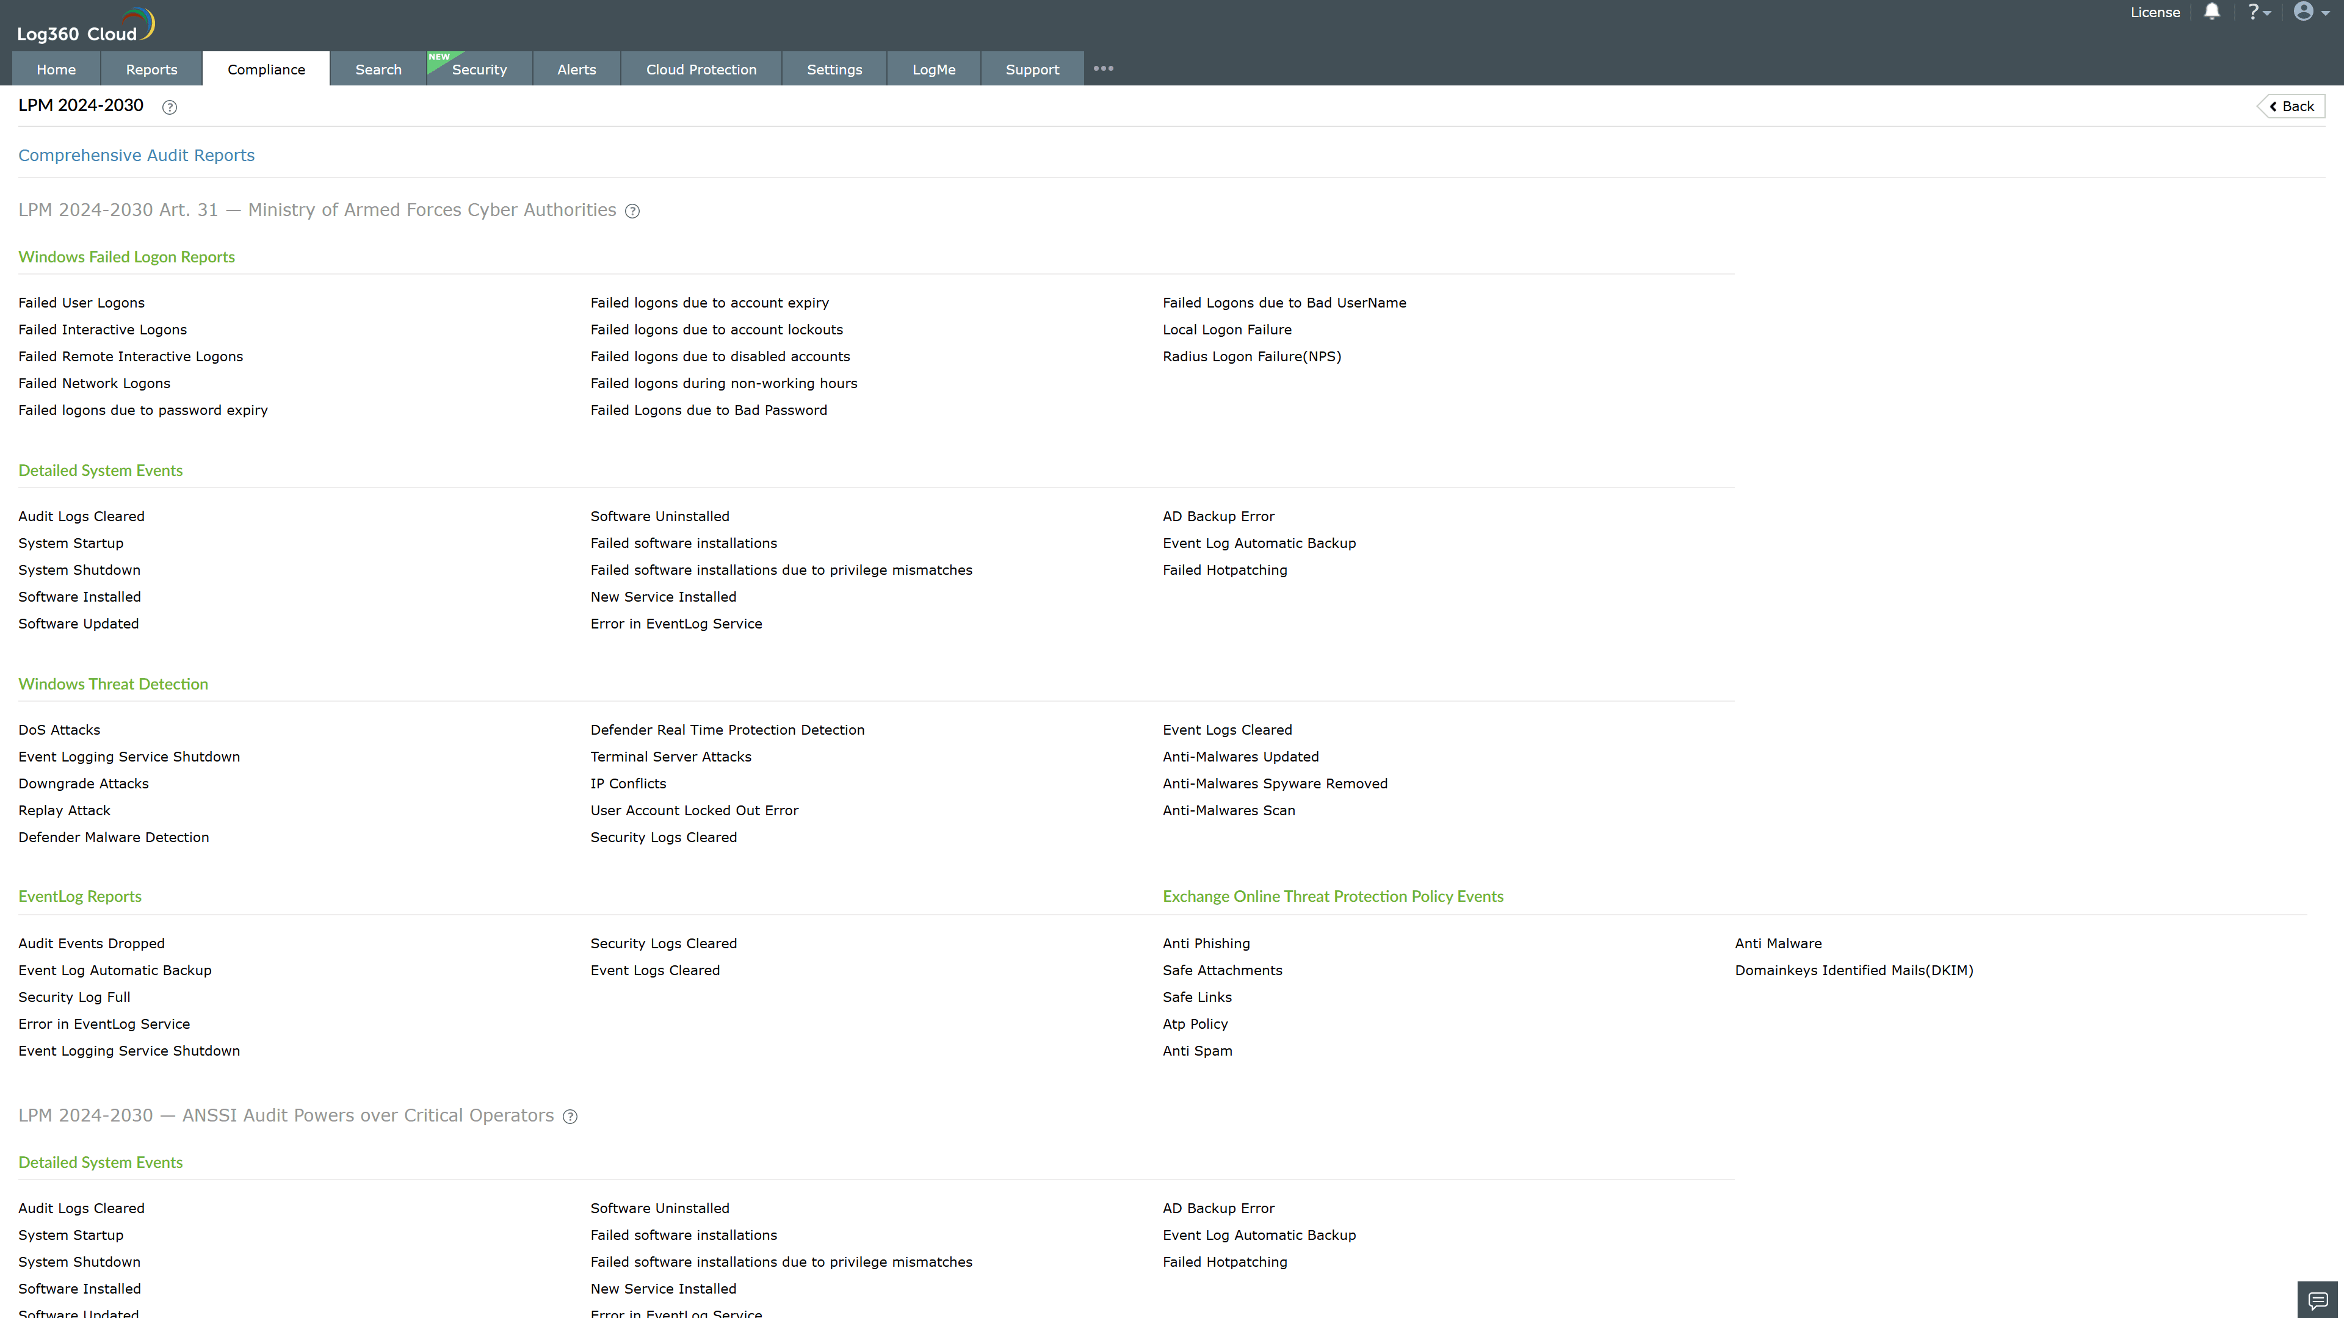
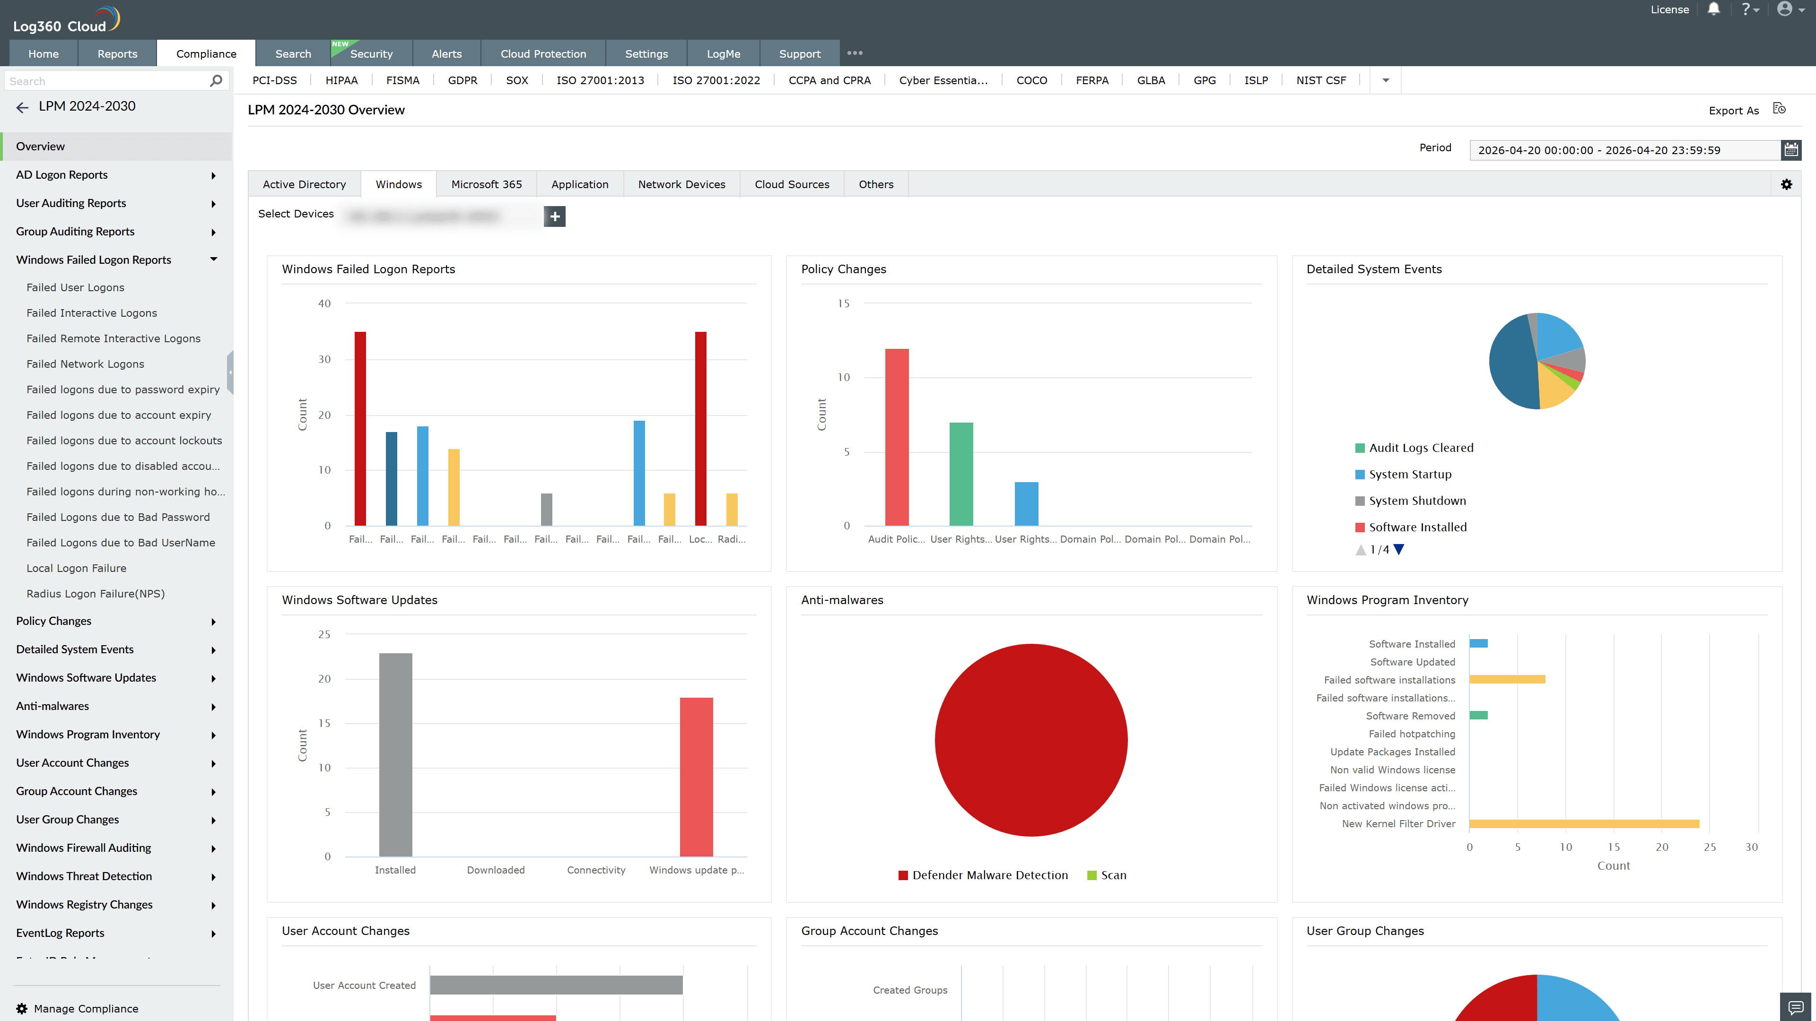
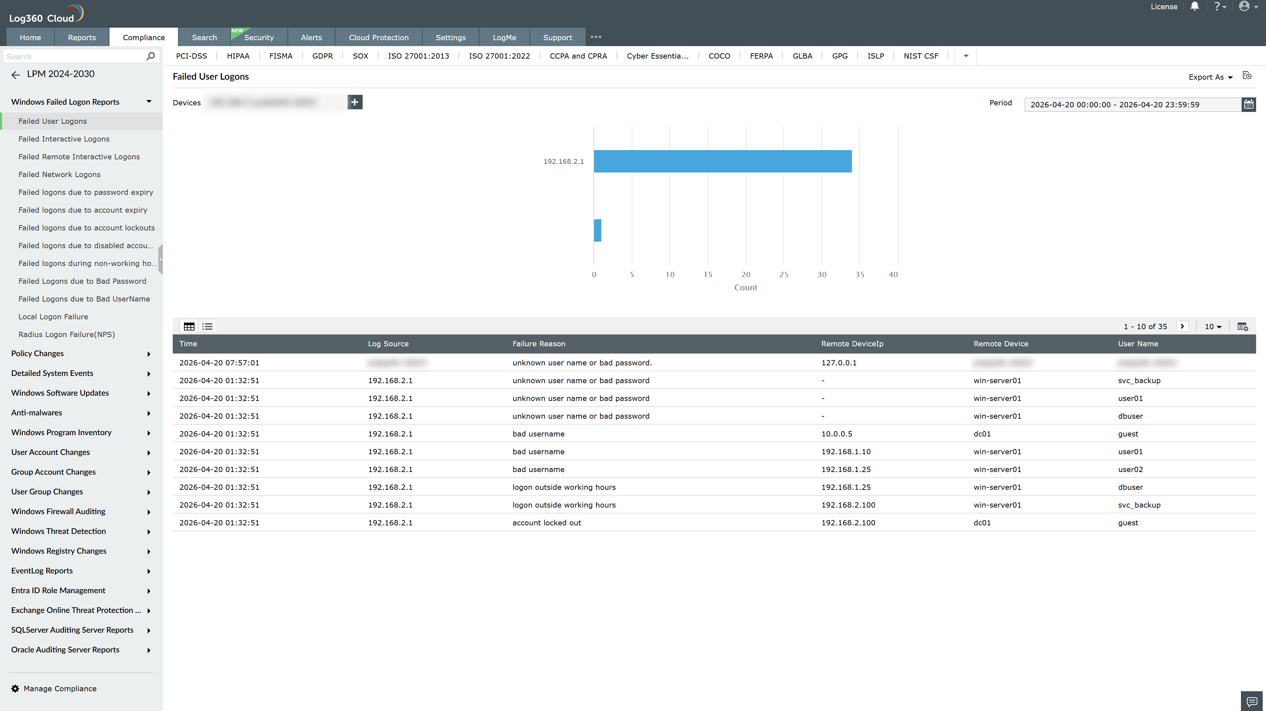
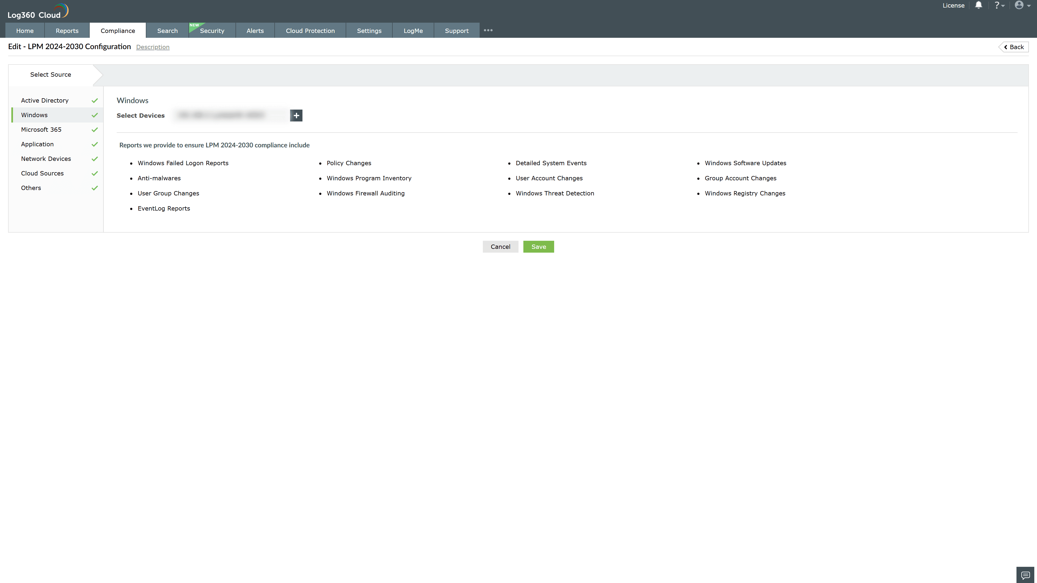

Valid Submission : Yes
Supported Editions : Free, Basic, Standard, Professional, MSSP
Help Document : https://www.manageengine.com/log-management/help/integrations/compliance-extensions.html
Help Video : Not provided
Tags : Log360, Compliance, Privacy monitoring, Data privacy, Regulatory compliance
Supported DCs : US, IN, JP, CA, AU, UK and EU
Privacy Policy:
Terms of Service:
Release Notes:
Predefined reports for the French Military Programming Act 2024-2030 (LPM) Compliance

